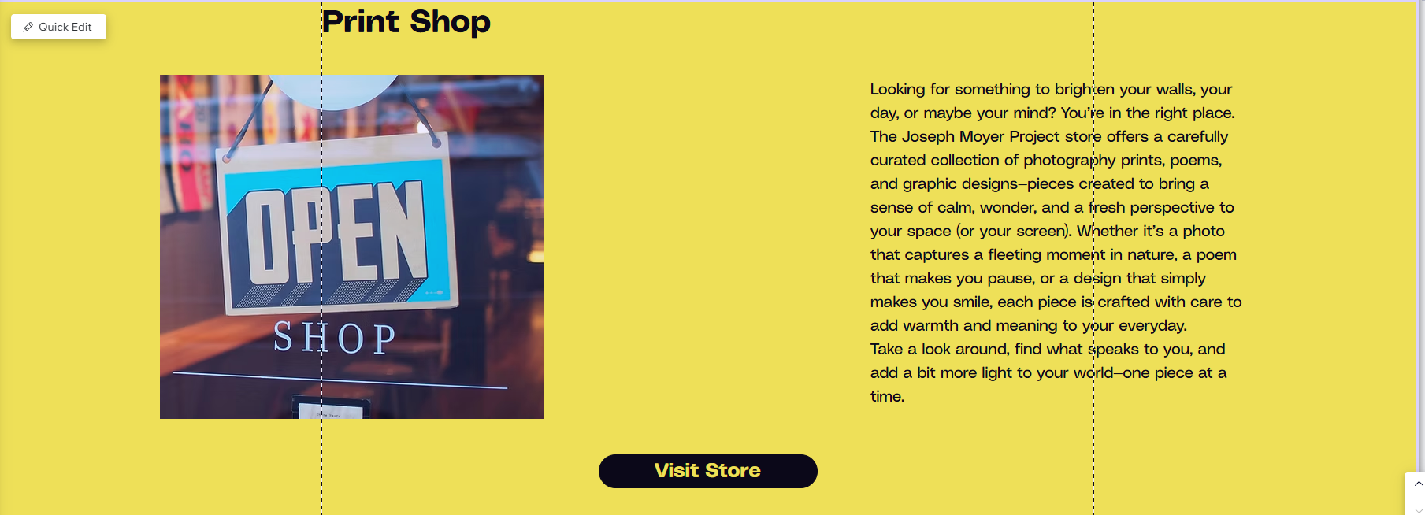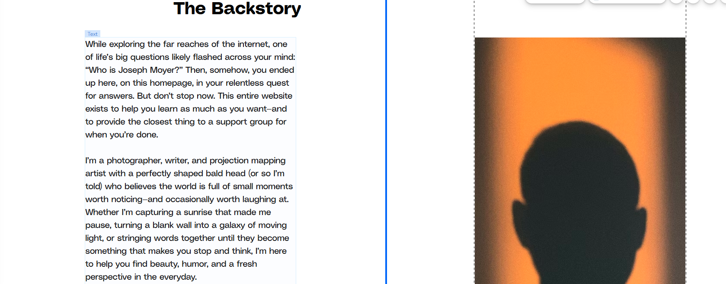


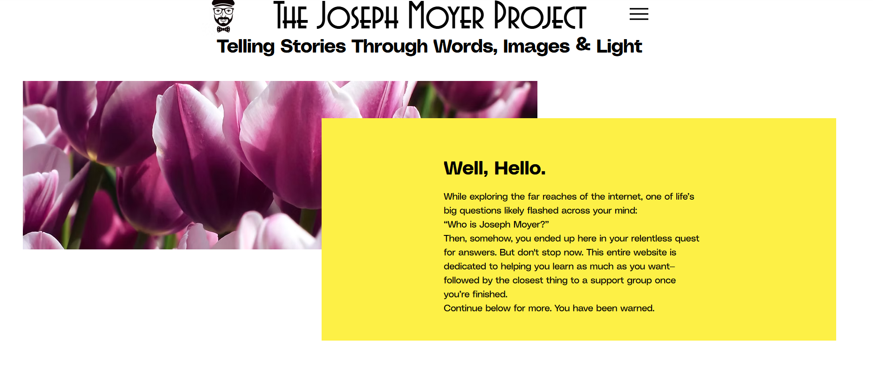
All About Me
I’m a photographer, writer, and projection mapping artist with a perfectly shaped bald head (or so I’m told) who believes the world is full of small moments worth noticing—and occasionally worth laughing at. Whether I’m capturing a sunrise that made me stop in my tracks, turning a blank wall into a galaxy of moving light, or stringing words together until they become something that makes you pause, I’m here to help you find beauty, humor, and a fresh perspective in the everyday.
If you’re curious about the guy behind the camera, I invite you to keep reading. And if you just want the gist, skip to the bottom for a brief summary.

​I’ve been called many things. The “coolest nerd ever” (possibly my mom), “crazy and obnoxious but still lovable,” and even—true story—“an excellent service dog.” That last one came from a guy who said he always smiled when I entered the room. I still don’t know whether to be flattered or concerned.

Whatever I am, I know this:
I love a good story.
​
Everyone has one. Twins raised in the same home will still see the world differently. That’s the magic. And I spend a lot of time trying to capture it—through photography, writing, video, and projection mapping. Whether it’s a sunrise, a poem, or a glowing universe projected onto the side of a building, I try to make things that make people feel something real.
​
I’ve been creating since I was a kid. Before the camera or keyboard, there were badly staged living room plays (sorry, Mom and Dad), mock radio shows with my sister, and enough daydreaming to require my own spoiler alert system. I moved on to capturing animals in the backyard with a camcorder and learned to tell stories with whatever tools I could get my hands on.
​
Somewhere along the way, I added photography, writing, design, video, and light-based art to my toolbelt. The styles change. The mediums evolve. But the heart of it—seeing the world with fresh eyes—has always stayed the same.
​
Now, thanks to this little corner of the internet, I get to share that work with you.
So—thank you for being here. I hope you find something that resonates, whether it’s a photo that brings you calm, a poem that stirs something up, or a projection that makes you stop and wonder.
If you want to see what’s new, explore the site. If you want to support the project, check out the shop. And if none of this is your thing… well, kindly lie to your friends and tell them I’m amazing.
(Disclaimer: I do not endorse lying. It’s a slippery slope that can end in serious injury and sometimes death.)
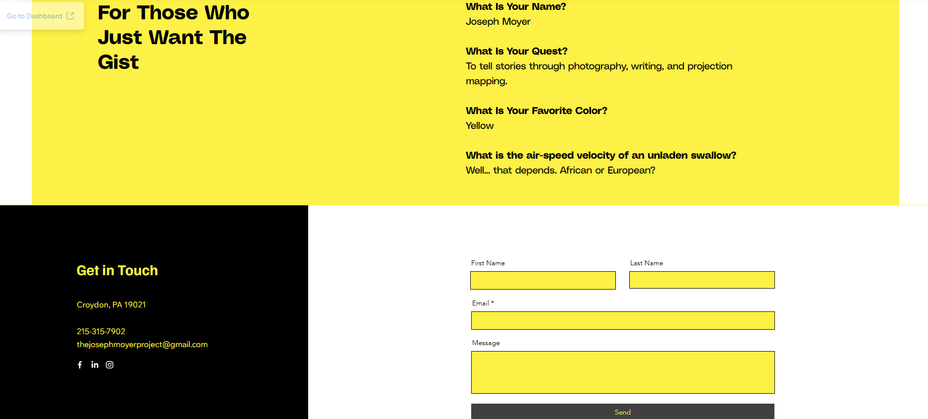
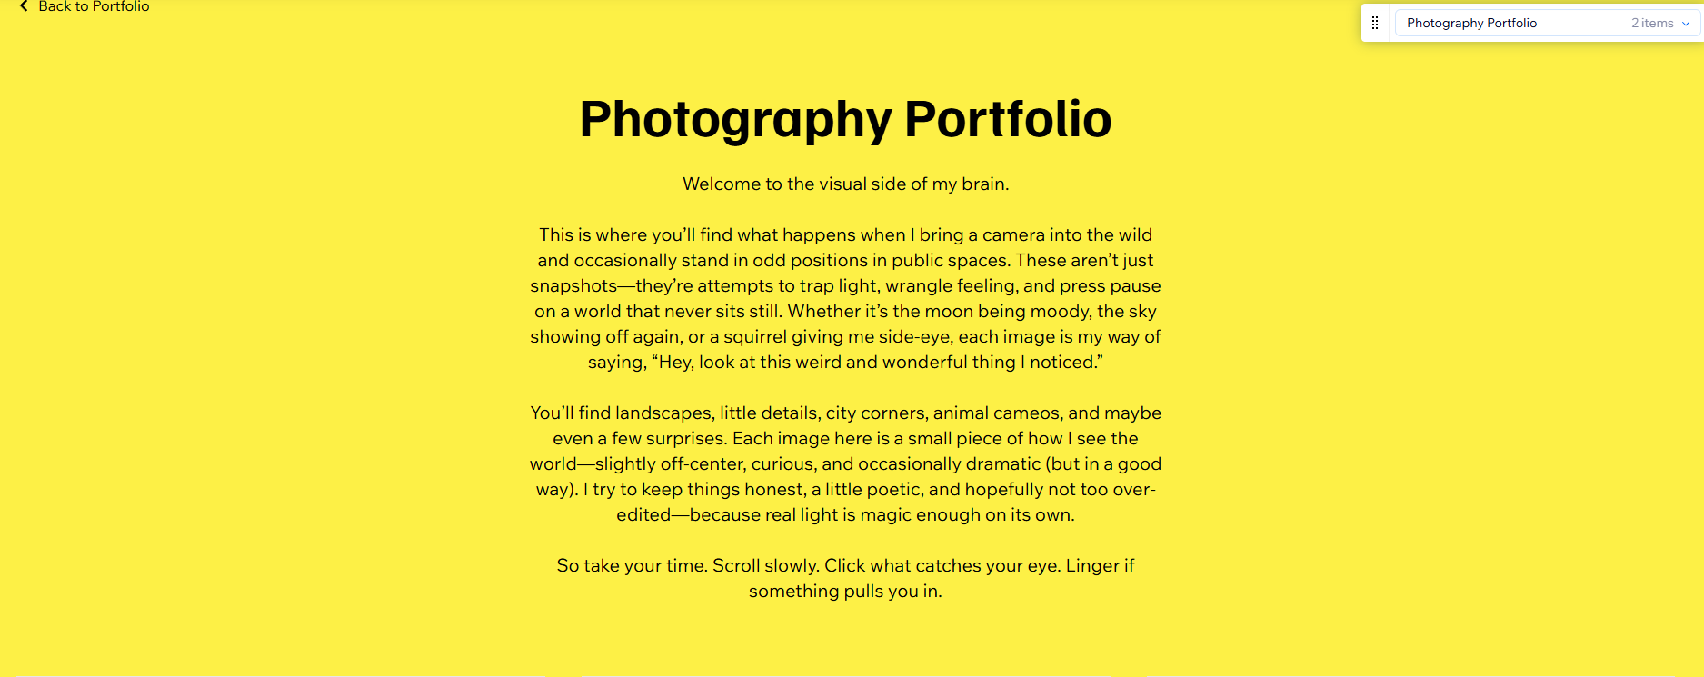
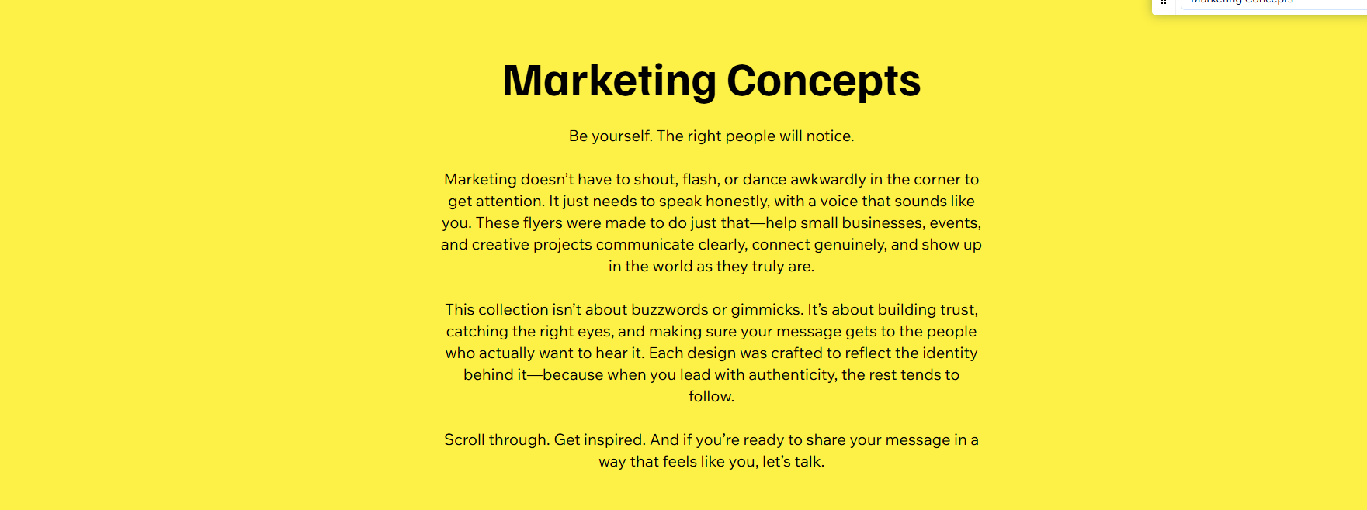

So… What Exactly Is Projection Mapping?
- 
Joseph Moyer
- Jul 30
- 3 min read
Let’s get something out of the way: projection mapping is not just “projecting images on a wall.” That’s called a PowerPoint. This is more like digital origami with light. You take a 3D object—like a building, sculpture, or dessert—and wrap it in motion graphics that fit it perfectly. The result? Something that feels a little like special effects… but in real life, and without needing a Marvel-sized budget.

Whether you’ve seen a giant cathedral shimmer like stained glass, or a pop concert where the stage folds into impossible shapes—chances are, you’ve seen projection mapping in action.

How Does It Work?
Think of it like tailoring a suit—except the suit is made of moving light, and the mannequin might be a wedding cake or a warehouse wall.

Here’s the short version:
- Measure or scan the object you’re mapping onto.
- Design visuals that match the object's shape, edges, and angles. (Think: animation, video, textures, effects.)
- Warp and align the visuals using software so they land exactly where they’re supposed to.
- Project it all using a high-lumen projector (translation: it needs to be bright enough to outshine your uncle’s iPhone flashlight).

It’s part technical wizardry, part digital puppetry, and part trial-and-error with snacks. The projector becomes a brush, the surface becomes the canvas, and the illusion becomes… well, kind of magical.

What Can You Do With It?
Good question. That’s where things get interesting.

Projection mapping has dozens of applications, from the practical to the poetic:
- Weddings: Imagine a cake that glows, sparkles, or tells your love story in animated scenes. It’s less messy than fireworks and a lot harder to forget.
- Events & Installations: Map an entire building for a block party. Animate a sculpture in a gallery. Turn a boring product booth into something people actually want to photograph.
- Theater & Performance: Set changes without lifting a finger. Environments that shift in real time with the emotion of a scene.
- Retail & Interior Design: Mood lighting that’s dynamic. Product displays that literally come to life.
- Home DIY: Okay, this one’s rare, but technically? If you’ve got a projector and a wall, you could be mapping right now.

Why I’m Picky About Projects
There’s no “template” for projection mapping. Every project is built from the ground up. So when I take something on, I want it to be worth the time, energy, and loss of sleep.

I'm especially interested in:
- Weddings with character (especially those where the cake is the star for five glorious minutes)
- Events that want a "wow" moment, not just a slideshow
- Small-scale experimental installations where art meets tech meets curiosity.

If you're just looking for a rented projector and someone to press play… that’s not me. But if you’re dreaming up something unusual, immersive, or just a little weird—in a good way—I’d love to hear about it.

A Quick Detour Into Inspiration
What inspires me? People. Stories. Everyday moments.

I’ve always been fascinated by the idea that everyone has a story. Even the person you sit next to on a train for five minutes—they’ve got decades of backstory, heartbreaks, victories, routines, and dreams you’ll never know about. That invisible richness—that’s what I try to tap into, whether I’m building a visual moment or capturing a quiet scene on camera.

I don’t create to explain things. I create to slow them down—so we can actually notice them.

Want to Try Projection Mapping?
Here’s what you need to know:
- It’s more accessible than you think. If you’ve got a projector, a laptop, and the ability to follow tutorials, you can start small at home.
- But for bigger stuff, you’ll want someone who knows what they’re doing (hi 👋).
- Most people don’t know it’s even an option. That’s why I do it.

So if you’re planning something and want it to stand out, consider projection mapping. It doesn’t just decorate a space—it transforms it.

Let’s Talk
If you're curious, reach out. I might not take every project—but if it’s got the right mix of creative spark, storytelling potential, and technical challenge, I'm all in.

Also, if you’re wondering what kind of projector I recommend, or whether your venue is even possible to map, I’m happy to chat about that too. No hard sell. Just real answers.

Everyone Has a Story- The Truths Behind My Writing
Joseph Moyer
- Jul 30
- 2 min read
I don’t write to explain things. I write to slow them down—so we can actually notice them. Otherwise, life flies by in a blur of text messages and weather updates, and we miss the really important stuff—like the way your new baby smiles at you when they first wake up or that feeling you get when you step on their left behind Lego.

We need to slow down and see the stories all around us. Even when I’m writing fiction, I don’t believe in “background characters.” That person with one line? The one who passes through the story like a desert wind without saying a word? They have years behind them. An entire backstory. Probably a favorite coffee mug and a childhood dream they still think about. Because that’s real life. You see someone on a train for five minutes, and you’ll never know what universe they’re carrying inside them.

That’s what writing is for—to imagine the rest. To capture and expound on what isn’t obvious.

In my head, every story has a soundtrack. Sometimes it’s piano. Sometimes it’s a cello in a minor key. And sometimes, yes, it’s that moody lo-fi loop you play when it’s raining and you want to feel mysterious while staring at your ceiling. The rhythm matters. The silences matter too. Especially the silences. You can learn a lot from what isn’t said.

I think stories—whether in prose or verse—are meant to be shared, reread, passed around like strange little keepsakes. They’re personal, but not private. That’s the thing about writing: it can start as a monologue and become a conversation without anyone asking permission.

Sometimes we write because we have something to say. Sometimes we write because we don’t know what to say. Most of the time, we write just to make sense of things. Or to remember them. Or to let them go. Or because our teacher says we have to fill a page at font size 12 and single spaced. You've probably fallen into one of those categories at least once.

And if you’ve ever read something that made you feel weird in a good way—like it tugged on a thread you didn’t know was loose—then you know how powerful that can be.

How to Experience Writing (Mine or Yours)
- Read it out loud. It sounds different in the air than in your head. Let it surprise you.
- Listen for the rhythm. Even if the beat’s just your own heartbeat.
- Let it sit. Not everything unfolds right away. Sometimes it’s a slow burn.
- Share it. With someone who needs it. With someone who won’t expect it.
- Write your own. Not for applause. Not for likes. Just to figure out what you’re carrying around.

We all have a story. Not a shiny, highlight-reel one—but the real, tangled kind. The kind made up of weird Tuesdays and half-remembered dreams and people who changed us without realizing it. The kind that deserves to be written down, even if no one else reads it.

So write it. Say it out loud. Keep it in a drawer or post it on your wall. Let it live somewhere.

Because at the end of the day, the world runs on stories. Not logic. Not algorithms. Not notifications.

Just stories.

And we should all be telling ours.

Welcome to The Joseph Moyer Project
Joseph Moyer
- Jul 30
- 2 min read
This isn’t just another “portfolio site.” This is The Joseph Moyer Project—a living, breathing collection of creative experiments, polished visuals, big ideas, and probably a little bit of sarcasm. Whether you're here to browse beautiful photography, curious about projection mapping, or you somehow clicked here by accident (hey, stick around), welcome.
At its core, this project is about exploration. I’m Joseph Moyer—a photographer, projection mapping artist, and occasional poet who believes creativity should feel like discovery, not a chore. This is where I share what I make, what I learn, and what I think is worth showing the world.

What I Do (and Why It’s Not Boring)

Photography
Let’s start with the lens. I shoot people, places, and fleeting moments—anything that tells a good story or captures emotion in a single frame. I’m especially drawn to texture, light, and quiet intensity. I don’t dump an entire SD card into a gallery—I pick the best, clean them up right, and make each shot count.
Want prints? Great. I offer museum-quality metal prints (because you deserve more than drugstore glossies) and a few more affordable options too. Some are even paired with original poetry, for those who like their art with a side of feelings.

Projection Mapping
Here’s the fun part: turning physical objects into living canvases. Whether it’s a building, a sculpture, or even a wedding cake (yes, really), I use light, motion, and storytelling to transform spaces. It’s immersive, it’s unexpected, and it’s where I feel most creatively alive.
This is the work I want to do more of. If you're a brand, a venue, or just someone with a wall and a dream—let’s talk.

Poetry + Prints
Sometimes the camera isn’t fast enough. That’s when I write. You’ll find original poems woven through my prints—words that feel like memories, little truths, or reminders we needed but didn’t know how to ask for. They're available as standalone prints or paired with photography.

(Future) Drone Work
I’m currently studying for my Part 107 certification to add aerial photography and videography to the mix. Soon, I’ll be taking creativity to the skies—with full FAA blessing.

What I Don’t Do
- I don’t mass-produce designs.
- I don’t say yes to every event.
- I don’t slap my name on projects I wouldn’t be proud of.
- I definitely don’t use Comic Sans.
This project runs on intention. I’m selective about the work I take on, the art I share, and the collaborations I say yes to. If that means fewer gigs and more meaning—perfect.

So, Why “The Joseph Moyer Project”?
Because this isn’t just a service list or a business card in website form. It’s an ongoing creative practice. A collection of experiments, commissions, and personal pieces that I believe in. It's a place for art that resonates—whether it's hanging in a gallery or glowing across a wall at midnight.

Stick Around
If you like what you see, don’t let this be a one-time visit. Come back often. The site evolves as I do. New work goes up. Ideas shift. Projects bloom. Whether you’re here to shop prints, book an installation, or just get inspired—I’m glad you’re here.
Welcome to the project.
Let’s tell a story.

Spotify- The Soundtrack of Creativity
Music is more than background noise—it's the unseen co-pilot of every great idea. Whether I’m mapping light onto a wedding cake or editing a photo until it politely agrees to be perfect, the right playlist keeps the momentum flowing and the imagination sparking.
​
That’s why I don’t just “throw on some tunes.” I build playlists the way some people build IKEA furniture—with care, precision, and a surprising amount of emotional investment. Each one is curated to boost creativity without ever getting in the way, full of clean, upbeat, and family-friendly tracks that even Grandma can tap her foot to (and she has impeccable taste).
​
You won’t find profanity, sketchy lyrics, or awkward transitions here. Just handpicked, mood-setting magic designed to make your brain smile and your to-do list slightly less intimidating.
​
Go ahead. Hit play. You’re about to soundtrack your day like the main character you are.

Privacy Policy
Effective Date: July 1 2025
Welcome to The Joseph Moyer Project, a personally designed and operated website where creativity comes to life through photography, writing, design, and projection mapping. This Privacy Policy explains how your information is collected, used, and protected when you visit or interact with the site at www.thejosephmoyerproject.com.
​
This website is proudly built and maintained by Joseph Moyer, and hosted through the Wix.com platform, which provides the tools used for design, content management, store transactions, and analytics.
​
Your privacy is important, and this policy is here to help you understand how your information is handled.
​
1. Who Operates This Website
This site is:
Owned, designed, and operated by Joseph Moyer
Hosted and supported via the Wix.com platform
Wix acts as the backend provider and may collect data necessary to provide secure site functionality and e-commerce tools. You can read Wix’s own Privacy Policy here for details on how their platform handles user data.
​
2. What This Policy Covers
This policy applies to everything on the site, including:
Browsing artwork, photography, writing, and projection mapping portfolios
Buying digital or physical items (prints, poems, designs, etc.)
Signing up for updates or email newsletters
Filling out contact forms (for collaborations, custom work, or projection inquiries)
Commenting (if enabled) on blog posts or content
Using the store checkout system (powered by Wix and/or third-party processors)
​
3. What Information Is Collected
Only the information you voluntarily provide is collected. This may include:
Your name
Email address
Shipping/billing address
Phone number (if entered)
Any message or inquiry you send
Purchase details (handled securely by Wix Payments, Stripe, PayPal, etc.)
Additionally, basic non-personal information is collected automatically for analytics and site improvement, such as:
Browser type and version
Device type
General location (region/country)
Pages visited and duration
Referring website or search engine
​
4. How Your Information Is Used
Your information may be used to:
Fulfill purchases you make through the shop
Send email updates (only if you subscribe or request it)
Reply to questions, requests, or collaboration inquiries
Improve the design, content, and experience of the website
Maintain site functionality and detect technical issues
Joseph Moyer does not and will not sell, rent, or share your personal information with marketers or third parties for profit. Period.
​
5. Payments and Store Security
All payments are processed through secure third-party services like:
Wix Payments
PayPal
Stripe
No banking or card information is stored on this site’s servers. Transaction data is encrypted and handled securely through these payment processors. If physical items are sold (e.g. photo prints), services like Printful or Printify may be used to fulfill orders, and they will receive the necessary shipping information only.
​
6. Cookies and Tracking Tools
Like most websites, this site uses cookies to improve performance and understand how visitors engage with content. These cookies may:
Remember your preferences
Track basic visitor behavior (e.g., what pages are popular)
Improve user experience
You can decline or delete cookies in your browser settings at any time.
Wix’s built-in analytics and Google Analytics (if enabled) may also collect anonymized browsing data. None of this is personally identifiable without your consent.
​
7. Third-Party Services
Some content and features rely on external tools, including:
Wix Apps and integrated features
Printful/Printify (for physical product fulfillment)
Social media integrations (e.g., Instagram feeds, Pinterest links)
Embedded videos or media (e.g., YouTube, Vimeo)
Email services (e.g., Wix Email Marketing or Mailchimp)
Each of these platforms follows its own privacy and data protection policies.
​
8. Your Rights
At any time, you may:
Request a copy of the personal data stored about you
Ask for corrections to that information
Request that your data be deleted
Unsubscribe from all email communications
Just send an email to: thejosephmoyerproject@gmail.com and your request will be handled promptly.
​
9. Children’s Privacy
This website is not directed to or intended for children under the age of 13. If you believe that personal information from a child has been collected, please contact us and it will be deleted immediately.
​
10. Security Measures
Security is taken seriously. The Wix platform uses SSL encryption, secure hosting, and other modern practices to protect your information. No system is perfect, but every reasonable effort is made to keep your data safe.
​
11. Updates to This Policy
This policy may be updated from time to time to reflect new site features, tools, or legal requirements. Any changes will be posted here with a new effective date.
​
12. Contact
Questions? Comments? A strong opinion about font choices? Reach out anytime.
Joseph Moyer
📧 thejosephmoyerproject@gmail.com
🌐 www.thejosephmoyerproject.com

Accessibility Statement
This statement was last updated on July 1 2025.

​At The Joseph Moyer Project, everyone is welcome. Whether you’re here to explore photography, soak in some writing, request projection mapping, or grab a print for your wall (or spaceship), this website is designed to be as inclusive and accessible as possible—because creativity should never have a gatekeeper.
​

Commitment to Accessibility
I am committed to providing a website that is accessible to the widest possible audience, regardless of technology, ability, or device. Whether you're using a screen reader, a keyboard instead of a mouse, high-contrast mode, or simply browsing on a tiny phone while lying upside down on the couch—I want your experience to be smooth and enjoyable.
​

Built on an Accessible Platform
This site is created through Wix, a platform that actively supports accessibility standards. Efforts have been made to:
- Use accessible fonts and clear contrast
- Ensure alt text is added to all meaningful images
- Use descriptive link text and proper heading structure
- Avoid flashing visuals or anything that might cause harm or disruption
- Make navigation logical and keyboard-friendly
​

Where I’m Still Improving
Accessibility is an ongoing effort, and while many features are in place, I recognize that perfect is a moving target. If you encounter any barriers—be it a button that’s hard to click, a font that’s tough to read, or a widget that ignores your polite keystrokes—I want to hear about it.
​

Contact
If you need assistance using this site or want to report an accessibility issue, please don’t hesitate to reach out:
📧 Email: thejosephmoyerproject@gmail.com
🌐 Website: www.thejosephmoyerproject.com
I’ll do my best to address the concern promptly and with care.

Shipping Policy
Effective Date: July 1 2025
​

Fulfillment & Shipping Process
Most items in The Joseph Moyer Project store—especially prints, posters, and apparel—are fulfilled through a trusted third-party production partner: Printful. Each product is made especially for you as soon as you place an order. That means a little extra time, but it helps reduce overproduction and waste. Thank you for making mindful purchasing decisions!
Estimated fulfillment time:
- Typically 2–7 business days depending on the item
- After fulfillment, shipping time is calculated and applied based on your location
Estimated shipping times:
- USA: 3–5 business days
- Canada: 5–10 business days
- Europe: 5–10 business days
- International: 10–20 business days
Note: These are estimates, not guarantees. Once an order leaves the production facility, it's in the hands of the shipping carrier. Unexpected delays (weather, customs, space-time anomalies) can happen.
​

Shipping Costs
Shipping costs are calculated at checkout and depend on your location, order size, and shipping method. Whenever possible, I aim to keep things affordable—without compromising on safe and secure delivery.
​

Tracking
You’ll receive a shipping confirmation email with a tracking number once your order is on its way. If your package seems lost or confused about its destination, don’t worry—reach out and we’ll help get it back on track.
​

Multiple Shipments
If you order multiple items, they may ship separately depending on what’s being fulfilled and where it’s being printed. That’s totally normal and no cause for alarm.
​

Customs & Import Taxes
International orders may be subject to customs fees or import taxes depending on your country’s policies. These fees are the responsibility of the buyer and are not controlled or collected by The Joseph Moyer Project or Printful.
​

Damaged or Lost Items
If your item arrives damaged or is lost in transit, please contact me within 14 days of delivery at thejosephmoyerproject@gmail.com. Include your order number, photos (if applicable), and a short description of the issue. I’ll work with Printful to get you a replacement as quickly as possible.

Terms & Conditions
Last updated: July 26, 2025
Welcome to The Joseph Moyer Project (thejosephmoyerproject.com). By accessing or using this website, you agree to the following Terms and Conditions. Please read them carefully. If you're not into long reads, just know this: be respectful, don't steal my work, and if you have questions—ask.
This site is created and maintained by Joseph Moyer using Wix.com, and may integrate with third-party services such as Printful, Spotify, or other creative tools. Use of this site is subject to both these terms and those of any third-party service providers where relevant.
​

1. Who Runs This Site?
This website is operated and designed by Joseph Moyer, a photographer, writer, projection mapping artist, and human of varied creative interests. All purchases, inquiries, and communications related to this site should go through:
📧 thejosephmoyerproject@gmail.com
​

2. Your Use of This Website
By using this website, you agree to:
- Use the content for personal and non-commercial purposes unless given explicit permission
- Respect intellectual property rights
- Avoid copying, modifying, or redistributing content without written consent
- Not engage in any activity that could disrupt the functionality, performance, or security of this website
In short: enjoy the site, share it with friends, but don’t republish my content as your own.
​

3. Intellectual Property
All content on this website—including images, text, artwork, projections, videos, designs, and downloads—is the intellectual property of Joseph Moyer unless otherwise credited.
You may not:
- Reproduce, distribute, or publicly display content without permission
- Use the logo, branding, or likeness for commercial gain
- Train AI models or bots using this content (seriously, don't)
You may:
- Share content via social media with attribution
- Use the content for inspiration (not duplication)
- Contact me if you'd like to license or collaborate on anything
​

4. Store & Products
Products available on this website (including photography prints, digital art, creative writing, and designs) are either fulfilled by Printful or delivered digitally.
By purchasing, you acknowledge that:
- Fulfillment and shipping times vary (see Shipping Policy)
- All sales are subject to availability
- Colors and appearances may vary slightly from what you see on screen (digital monitors and physical ink are not always best friends)
- Refunds and returns are handled as described in the Refund Policy
​

5. Third-Party Services
This website is hosted and built on Wix.com, and uses integrated services like:
- Printful (product fulfillment)
- Stripe or Wix Payments (payment processing)
- Google Analytics or Wix Analytics (site performance and analytics)
Your use of these services is also governed by their individual terms and policies.
​

6. Privacy & Data Collection
For a full understanding of what data is collected and how it’s handled, please read the Privacy Policy. In short:
- I won’t sell your data
- Your information is only used for orders, communication, and site analytics
- You can request to update or delete your data at any time by emailing thejosephmoyerproject@gmail.com
​

7. Accessibility
This website is designed to be inclusive and user-friendly for as many people as possible. For details, check out the Accessibility Statement. If you encounter any barriers while navigating the site, let me know—I'll do my best to help.
​

8. Changes to the Terms
Things evolve. Technologies shift. Occasionally, I update these terms to reflect changes in services or policies. All updates will be posted here. Your continued use of the site means you accept the latest version of the terms.
​

9. Legal Stuff
- These terms are governed by the laws of the United States (and Pennsylvania, to be more specific).
- Any disputes arising from use of the site shall be resolved in good faith and, if necessary, through appropriate legal means.
- This is a personal website, not a multinational corporation. So let’s try to be decent humans about everything.
​

10. Contact
Got questions? Concerns? Good jokes?
Email me at: thejosephmoyerproject@gmail.com

Refund Policy
Last updated: July 26, 2025
​
Thanks for supporting The Joseph Moyer Project. Each product is made just for you when you place your order—whether it’s a photo print, design piece, or something wonderfully weird from the creative corner of my brain.
That said, here’s how refunds and returns work around here.
​

All Sales Are Final
Because items are printed and fulfilled on demand via Printful, I cannot accept returns, exchanges, or refunds for:
- Buyer’s remorse
- Incorrect sizing or color choice
- Slight color differences due to screen vs. print
- Items delivered to the wrong address due to customer error
Please double-check your order details before submitting—and if you’re unsure about anything, email me first. I’m happy to help clarify things in advance.
​

Damaged, Misprinted, or Defective Items
Now, if something shows up looking like it fought a raccoon on the way to your mailbox, we’ve got a problem. If your item arrives:
- Misprinted
- Damaged
- Defective in any way
You must report it within 30 days of receiving the product. Email thejosephmoyerproject@gmail.com with:
- Your order number
- A clear photo of the issue
- A description of what’s wrong
Once verified, I’ll work with Printful to provide a free replacement or full refund.
​

Lost or Stolen Packages
Unfortunately, once an order ships, it’s out of my hands (literally). If your package is marked as delivered but nowhere to be found:
- Check with neighbors, roommates, building managers, or secret underground lairs
- Wait a day or two—it may still show up
- Contact your local carrier with the tracking info
If all else fails, shoot me an email and we’ll see what can be done. I can’t guarantee refunds for lost or stolen items, but I’ll do my best to help.
​

Questions?
Need to report a problem, ask a question, or send a photo of your order in its new natural habitat?
📧 thejosephmoyerproject@gmail.com
I’m here to make sure you’re happy with your experience—and if something’s gone sideways, I want to help make it right.

Photography Portfolio
Welcome to the visual side of my brain.

This is where you’ll find what happens when I bring a camera into the wild and occasionally stand in odd positions in public spaces. These aren’t just snapshots—they’re attempts to trap light, wrangle feeling, and press pause on a world that never sits still. Whether it’s the moon being moody, the sky showing off again, or a squirrel giving me side-eye, each image is my way of saying, “Hey, look at this weird and wonderful thing I noticed.”

You’ll find landscapes, little details, city corners, animal cameos, and maybe even a few surprises. Each image here is a small piece of how I see the world—slightly off-center, curious, and occasionally dramatic (but in a good way). I try to keep things honest, a little poetic, and hopefully not too over-edited—because real light is magic enough on its own.

So take your time. Scroll slowly. Click what catches your eye. Linger if something pulls you in.

Portfolio Top Menu Button Leads to Portfolio Page
Portfolio Button in hero leads to portfolio page
Portfolio Page only has the following options

Photography Sub-Portfolio has the following collections
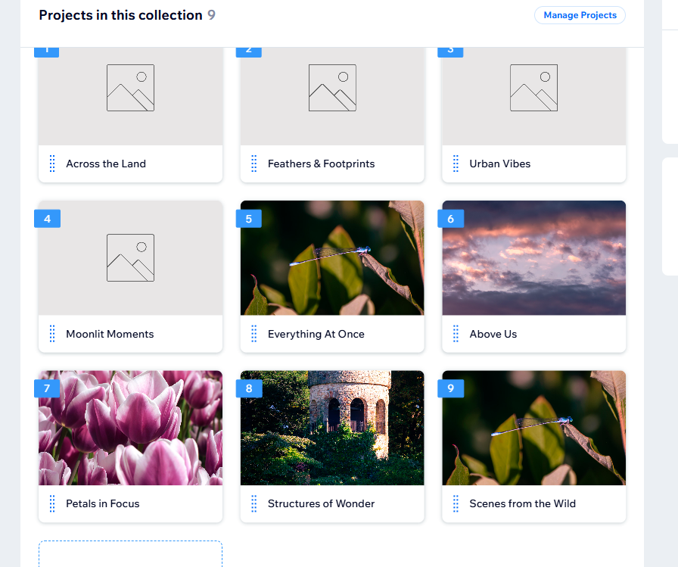
Creative Writing Sub-Portfolio Has the Following Collections
- Poems
- Visualizations (Link to Youtube Page not yet created)
Projection Mapping SubPortfolio simply leads to a gallery.
The Marketing & Design SubPortfolio should have the following collection (more to come)
- Physical Therapy Flyers

Ever looked at a wall and thought, “This could use more galaxies?” Same.

Projection mapping lets me transform everyday surfaces into moving art—walls become windows, buildings become storytellers, and suddenly, light isn’t just for seeing, it’s for feeling. What you’ll find below is a glimpse into the experiments, installations, and occasional "did that just happen?" moments I’ve created using pixels, projectors, and probably too much coffee.

Whether it’s immersive art for a gallery, ambient visuals for a live performance, or turning someone’s garage into a swirling nebula, I love bending light to surprise people—and occasionally confuse their cats.

Take a look around, and if your walls are feeling a bit two-dimensional, we should definitely talk.

Some people write to inform. I write to escape, explore, unravel, and occasionally to avoid folding laundry.

Here you’ll find an evolving collection of poems, essays, short stories, and mildly suspicious thoughts that insisted on being written down. Whether it’s a quiet line that sneaks up on you, or a full-blown narrative detour that asks you to buckle up and keep your arms inside the metaphor at all times—this is where my words live when they’re not wandering elsewhere.

From observational scribbles to quiet truths wrapped in humor, each piece is a window into how I see the world: a bit strange, mostly beautiful, and occasionally narrated in a voice not unlike David Attenborough’s (but less British and far less credible).

Read a few. Or all of them. Or just pretend you did and quote something out of context at a dinner party—I won’t stop you.

Be yourself. The right people will notice.

Marketing doesn’t have to shout, flash, or dance awkwardly in the corner to get attention. It just needs to speak honestly, with a voice that sounds like you. These flyers were made to do just that—help small businesses, events, and creative projects communicate clearly, connect genuinely, and show up in the world as they truly are.

This collection isn’t about buzzwords or gimmicks. It’s about building trust, catching the right eyes, and making sure your message gets to the people who actually want to hear it. Each design was crafted to reflect the identity behind it—because when you lead with authenticity, the rest tends to follow.

Scroll through. Get inspired. And if you’re ready to share your message in a way that feels like you, let’s talk.

